.

Design Document for PREQ967

Status: | Issued
Version: | 4.0
Author: | Simon Conway, Joe Xiao, Cemile Otkunc, Pauline Pan
Reviewers: | Stephen Mansfield, Simon Conway
Team/Department : | System Libraries/Core Development

Contents
1 Introduction 3
1.1 Purpose and Scope 3
2 Design Overview 3
2.1 Phase II Modifications 4
3 Detailed Design 5
3.1 ECOM Server 5
3.1.1 CEComServer 5
3.1.1.1 Production Code 5
3.1.1.2 Unit Tests 5
3.1.2 CServerStartupMgr 6
3.1.2.1 Production Code 6
3.1.2.2 Unit Test Code 8
3.1.3 MStartupStateObserver 10
3.1.3.1 Production Code 10
3.1.3.2 Unit Test Code 10
3.1.4 CRegistryData 11
3.1.4.1 Production Code 11
3.1.4.2 Unit Test Code 12
3.1.5 CDiscoverer 13
3.1.5.1 Production Code 13
3.1.5.2 Unit Test Code 14
3.1.6 CRegistrar 16
3.1.6.1 Production Code 16
3.1.6.2 Unit Test Code 16
3.1.7 ECOM Component Tests 17
3.1.8 ECOM Component Integration Tests 17
3.1.9 ECOM Regression Test Code 17
3.2 ECOM Client Library 18
3.2.1 Possible for Client to Select Plugin Based on Incomplete List 18
3.2.1.1 Current Behaviour 18
3.2.1.2 New Behaviour 18
3.3 Phase II Modifications 19
3.3.1 MDiscovererObserver 19
3.3.2 CRegistrar 19
3.3.3 CRegistryData 19
3.3.3.1 ValidateRegistry Method 19
3.3.3.2 PersistNowL Method 19
3.3.3.3 BuildIndexesL Method 20
3.3.3.4 Other Changes 20
3.3.4 CDiscoverer 20
3.3.4.1 CEComServer 20
3.3.4.2 CServerStartupMgr 20
4 Further Information 21
4.1 Open Issues 21
4.2 References 21
4.3 People 21
4.4 Document History 21

Introduction

Purpose and Scope
This document describes the changes required to ECOM to make it Start-Up State Aware (SSA), in order to satisfy the requirements of PREQ967 – Start up phone first, phase 2. See [R1] for project information.
This PREQ is required for 9.2 (Bravo). The PTS for this PREQ is SMG.
The target audience that this document is intended includes the TA and engineers within System Libraries, SMG, Test Engineering and the PM responsible for the PREQ delivery.

Design Overview
PREQ967 requires that ECOM becomes SSA. This means that ECOM must coordinate its plugin discovery with the System Start-Up States made available by the Domain Manager. The Domain Manager gets System Start-Up States from System Starter.
ECOM will discover all plugins on RO internal drives at Critical-Static state, and discover all other plugins at Non-Critical state.
ECOM will ‘catch up’ its discovery of plugins depending on the start-up state received. i.e. If the first state that ECOM becomes aware of is Non-Critical state then a full discovery of all plugins must occur.
Licensee’s may extend the number of states in the state machine. These states will be ignored by ECOM.
ECOM will continue to be launched by the first client that requires its services. It will not be launched by System Starter.
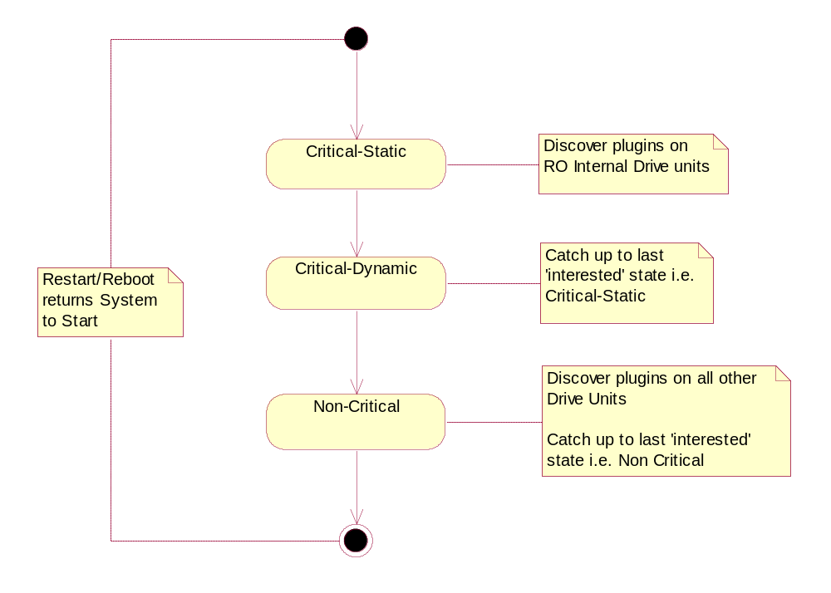
Figure 1: State Machine for Symbian Defined Start-Up States

Phase II Modifications
The performance test results showed that the non-critical state of ECOM server start-up required performance improvements. Further investigation showed that CregistryData::DiscoveriesCompleteL method is repeating functionality that has already been performed during previous states. E.g. the plug-ins that have been validated, persisted at critical-static state of ECOM server are being re-validated, re-persisted at non-critical state. Phase II design of PREQ967 focuses on improving CregistryData functionality during start-up.

Detailed Design

ECOM Server

CEComServer
This is an existing class that needs updating to initialise ECOM to work in a state driven environment.

Production Code
- CEComServer must be modified as follows:
- Instantiate instances of Cregistrar and CregistryData.
  - Add new public static method Tbool IsSSA() that reads the EcomSrvr.ini file to determine if ECOM should be SSA or not.
- The default should be that no ini file will exist. This will result in SSA being on.
- The EcomSrvr.ini file can exist on either Z or C drive. Z drive should be read first, if the EcomSrvr.ini file does not exist, C drive will be read.
- If an EcomSrvr .ini file exists then the SSA will be off.
- If file read operation fails, SSA on should be returned.
- The return value of IsSSA() should be cached. Subsequent calls to IsSSA() should use the cached value rather than interrogate the ini file again.
- Instantiate instance of CserverStartupMgr.
- Register Cregistrar and CregistryData with CserverStartupMgr using RegisterObserver().
- Call CserverStartupMgr::Initialise().
- EcomSrvr.ini:
  - The existence or non-existence of this file turns the SSA behaviour off or on respectively.
  - A single method called IsSSA() will be implemented to read this file and determine if SSA is enabled or not. It will return Tbool.
  - For this project a separate class will not be written to manage the reading of this file as it is used for turning on or off of a single setting. In the future, if the file gets more complicated, a separate class may be necessary.
  - This file can reside in one of Z:\private\10009D8F\EcomSrvr.ini and C:\private\10009D8F\EcomSrvr.ini locations or both.
- Configurability
This code will be non-configurable.

Unit Tests
- IsSSA() Tests
- With no EcomSrvr.ini file ensure IsSSA() returns ETrue.
- With EcomSrvr.ini file existing ensure IsSSA() returns Efalse.

CserverStartupMgr
This is a new object that interacts with the Domain Manager to ensure it is kept aware of the current system start-up state. It will distribute start-up state changes to interested MStartupServerStateObserver objects within ECOM.
[R2] and [R3] were used as reference for the design of this new object.

Production Code
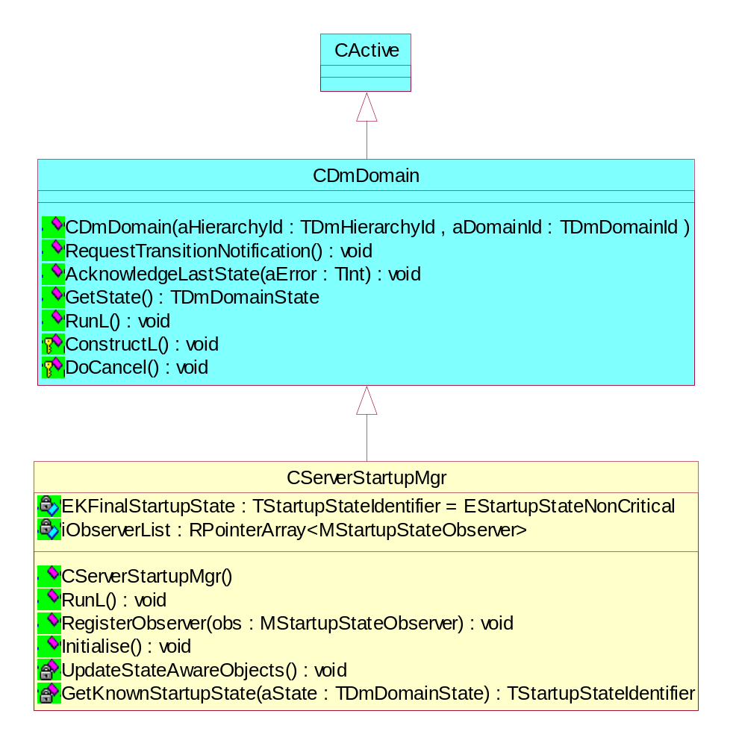
Figure 2: Class Diagram for CserverStartupMgr
- The code definition and implementation for this class will be held in ServerStartupManager.h and ServerStartupManager.cpp respectively.
- Owned and instantiated by CEComServer.
- Holds a list of MstartupStateObserver objects. Each of these objects will be notified of system state changes by calling their ProcessSSAEvent() method. CEComServer will register these objects by calling RegisterObserver() for each.
- Inherits from CdmDomain (see domainmember.h) making it an Active object.
- Initialise() will use CEComServer::IsSSA() to determine if ECOM should be SSA or not.
When SSA is Off:
- Set each MStartupServerStateObserver object to it’s final state by calling ProcessSSAEvent () for each and passing the Non-Critical state. This will cause each MStartupServerStateObserver object to ‘catch up’ to it’s final state in turn which is the same as a full discovery.
When SSA is On:
- It will connect to BSD3 (Base Services Domain 3) by using the CdmDomain constructor and then calling ConstructL(). ConstructL() will leave if a connection to the BSD3 domain cannot be made. If ConstructL() leaves then this object will set each MStartupServerStateObserver object to its final state by calling ProcessSSAEvent () for each and passing the Non-Critical state. This will cause each object to ‘catch up’ to their final state in turn which is the same as a full discovery.
- It will request System Start-up state notifications by calling inherited member RequestTransitionNotificationL() so that ECOM does not miss any Start-up state changes during its initialization.
- It will determine the current Start-Up state by calling inherited member GetState().If an invalid Start-Up state is returned, there is a system error, or the final state has been reached it will set each MStartupServerStateObserver object to its final state by calling ProcessSSAEvent() for each, and cancel any outstanding request for System Start-up states notifications.
- For start-up states that ECOM is not interested determine the previous known start-up state, sequentially, that it is interested in. Using this state advise all MStartupServerStateObserver objects by calling ProcessSSAEvent () for each. To ensure integrity all states will be received sequentially.
- RunL() will:
  - Be executed for each system Start-up state change.
  - Request System Start-up state notifications by calling RequestTransitionNotificationL() in order not to miss state changes that may happen when it is processing a state change event.
  - Advise all MStartupServerStateObserver objects that the state has changed by calling ProcessSSAEvent () for each. This will cause each object to synchronously ‘catch up’ to the state set.
  - For start-up states that ECOM is not interested determine the previous known start-up state, sequentially, that it is interested in. Using this state advise all MStartupServerStateObserver objects by calling ProcessSSAEvent () for each. To ensure integrity all states will be received sequentially.
  - Call AcknowledgeLastStateL() when ECOM has completed processing for this state.
  - If the current System Start-up state is EKFinalStartupState. or any system error, it will cancel any outstanding request for System Start-up states notifications.
- An implementation of RunError() will be provided as it is possible for RunL() to leave.
- Testability
  - To allow unit test code to access protected and private data and operations the test class TserverStartupMgr_StateAccessor will be made a friend of CserverStartupMgr.
  - A test harness version of CdmDomain will be used for the unit testing of CserverStartupMgr. The test harness version of CdmDomain is called CdmDomainTestHarness. The production code will selectively include headers for either the production implementation or the test harness implementation using the macro __ECOM_SERVER_TESTABILITY__. This will be defined in the test harness MMP file. It is also enabled or disabled in the group/EcomTest.hrh file.
For example the production code will be:
#ifndef ____ECOM_SERVER_TESTABILITY__
#include “domainmember.h” // production header
#else
#include “testharnessdomainmember.h” // test harness header
#endif
- Configurability
This code will be non-configurable.

Unit Test Code
- A Test Harness class CdmDomainTestHarness is required for unit testing. This class acts as a dummy class that passes all the calls to the CdmDomain class if the c:\\EcomTestBehaviour.ini file exists. Otherwise CdmDomainTestHarness class blocks all the calls and allows the users of this class to mimic the domain manager functionality.
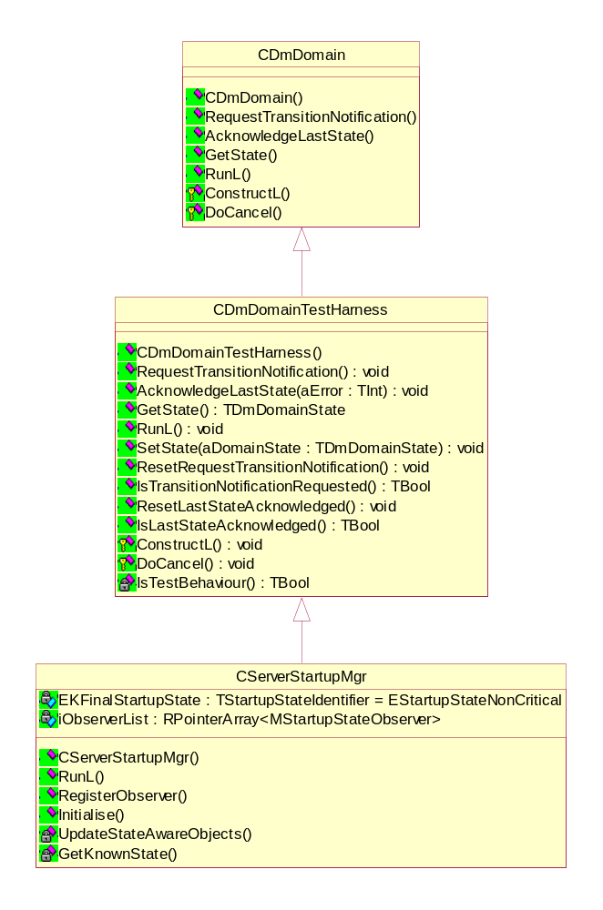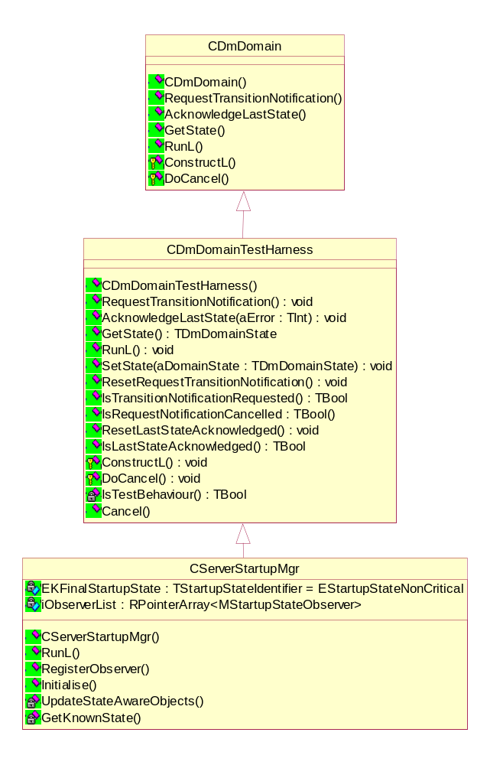
Figure 3: Class Diagram for CserverStartupMgr and Test Version of CdmDomain
A TserverStartupMgr_StateAccessor object is required for unit testing. This class will allow access to the protected and private data and operations of CserverStartupMgr.

- The following new unit tests are required:

  - GetKnownStartupState() Tests
For the following start-up state values EstartupStateUndefined, EstartupStateUndefined+1, EstartupStateCriticalStatic-1, EstartupStateCriticalStatic, EstartupStateCriticalStatic+1, EstartupStateCriticalDynamic-1, EstartupStateCriticalDynamic, EstartupStateCriticalDynamic+1, EstartupStateNonCritical-1, EstartupStateNonCritical, EstartupStateNonCritical+1 ensure that the correct known start-up state is returned.
  - InitialiseL() Test when SSA is disabled
    - Check that each MStartupServerStateObserver object is set to their final state after InitialiseL() completed.
    - Check that CserverStartupMgr is set to its final state: EstartupStateNonCritical
  - InitialiseL() Test when SSA is enableds
    - Check that each MStartupServerStateObserver object is set to their final state when CdmDomain::ConstructL() leaves.or when each of the following known start-up state EstartupStateUndefined, EstartupStateCriticalStatic, EstartupStateCriticalDynamic, EstartupStateNonCritical is processed ensure that each MStartupServerStateObserver object is set to their corresponding state.
    - Ensure RequestTransitionNotificationL() is always called first after CdmDomain::ConstructL() is called successfully.
    - For EstartupStateNonCritical or any system error, ensure that Cancel() is called to cancel outstanding request.
  - RunL() Tests
    - Ensure RequestTransitionNotificationL() is always called first.
    - For each following known start-up state EstartupStateUndefined, EstartupStateCriticalStatic, EstartupStateCriticalDynamic, EstartupStateNonCritical ensure that each MstartupStateObserver object is set to their corresponding state.
    - For each state ensure that AcknowledgeLastStateL() was called.
    - For EstartupStateNonCritical or any system error, ensure that Cancel() is called to cancel outstanding request.
- Configurability
This code will be non-configurable.

MstartupStateObserver
This is a new class that all objects, interested in system start-up state changes, must inherit from.
e.g. Cregistrar, CregistryData
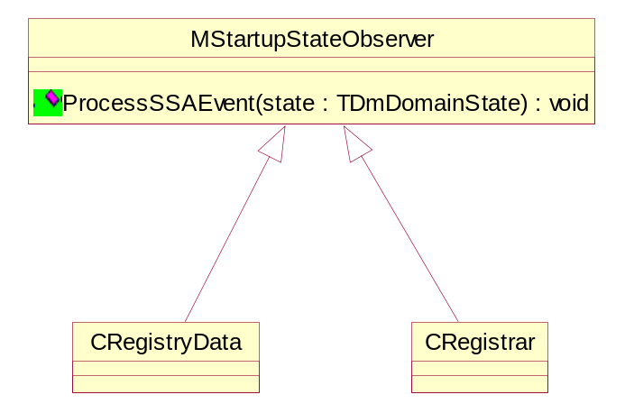
Figure 4: Class Diagram for MstartupStateObserver

Production Code
This class is an interface class. It is used as a base for all classes that wish to be notified of system start-up state changes.
- Configurability
This code will be non-configurable.

Unit Test Code
No unit tests are required for this class.

CregistryData
This is is an existing class that will be updated to make it state driven.
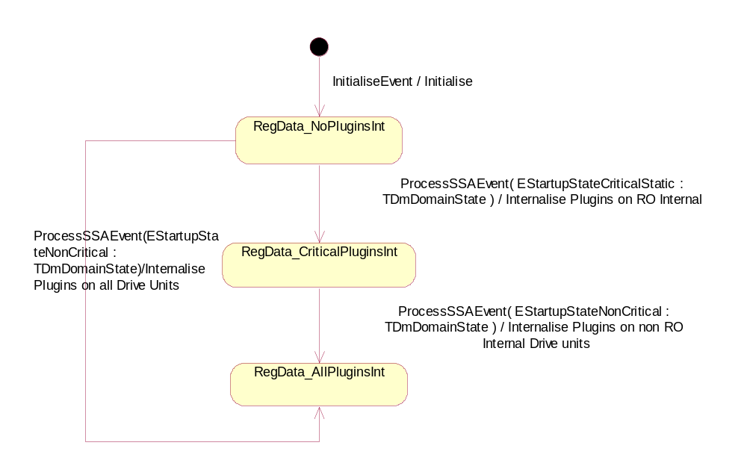
Figure 5: State Machine for CregistryData

Production Code
- The following changes will be made:
    - Update so it inherits from MstartupStateObserver.
    - Modify ConstructL() so that it no longer does internalisation.
    - Add InitialiseEvent() and call during construction. See state diagram above.
    - Add iState data member to class to hold the objects current state.
    - Add void ProcessSSAEvent(TdmDomainState aState). It will be used by CserverStartupMgr to notify the object of system start-up state changes. The event may or may not cause the object to move to another state. The allowed transitions are identified in the state diagram shown above.
    - Add RDState GetState() to retrieve the objects current state.
    - Update existing internalize code to be state driven. Code will only internalize pertinent drive units for each state. See state diagram.
    - CregistryData::BuildIndexes() must be updated as follows:
    - For implementations with the same uid a decision must be made to determine which is to be added to the index list. When this occurs the implementation that is added to the index list must be the same as that selected before ECOM was made SSA.
i.e. After CregistryData::BuildIndexes() has been executed the contents of the index list must be identical to the index list created by CregistryData::BuildIndexes() pre PREQ967.
- CregistryData::BuildIndexes() will be called in void ProcessSSAEvent(TdmDomainState aState) method when every ECOM interested state(EstartupStateCriticalStatic, EstartupStateNonCritical) is received.
- Testability
- A class called TregistryData_StateAccessor already exists to allow unit test code to access protected and private data and operations.
- Configurability
This code will be non-configurable.

Unit Test Code
- The following new unit tests are required:
  - Discovery when SSA is disabled
  - After construction check that initial state is RegData_NoPluginsInt and check that the Registry is empty.
  - Call ProcessSSAEvent (TdmDomainState aState) with aState set to Non-Critical. Check that a plugin from Ecom.Z.dat file on the Z: drive has been registered. Check that a plugin from Ecom.dat on the C: drive has been registered. Check that the current state is RegData_AllPluginsInt.
  - Discovery when SSA is enabled
  - After construction check that initial state is RegData_NoPluginsInt and check that the Registry is empty.
  - call ProcessSSAEvent(TdmDomainState aState) with aState set to Critical-Static. Check that a plugin from Ecom.Z.dat file on the Z: drive has been registered. Check that the current state is RegData_CriticalPluginsInt.
  - Call ProcessSSAEvent (TdmDomainState aState) with aState set to Non-Critical. Check that a plugin from Ecom.dat on the C: drive has been registered. Check that the current state is RegData_AllPluginsInt.
  - Call ProcessSSAEvent (TdmDomainState aState) with aState set to various states that will not cause a transition (see state diagram). Do tests again with CregistryData in different states. Check that the current state remains unchanged.
- Configurability
This code will be non-configurable.

Cdiscoverer
This is an existing class that will be updated to make it state driven.
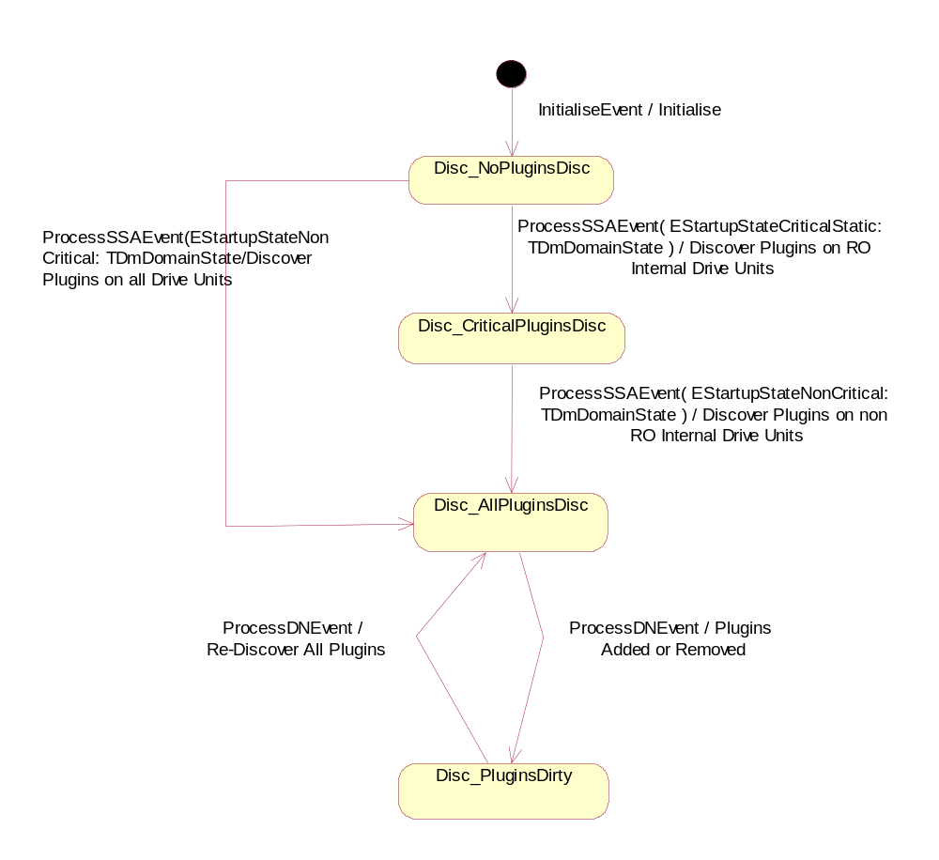
Figure 6: State Machine for Cdiscoverer

Production Code
Cdiscoverer does not inherit from MstartupStateObserver because it is not registered with CserverStartupMgr.
Cregistrar encapsulates Cdiscoverer and calls ProcessSSAEvent() when its own ProcessSSAEvent() is called.
- The following changes will be made:
    - Modify ConstructL() so that it no longer does a discovery.
    - Add InitialiseEvent() and call during construction. See state diagram above
    - Add iState data member to class to hold the objects current state.
    - Add void ProcessSSAEvent(TdmDomainState aState). It will be used by Cregistar to notify the object of system start-up state changes. The event may or may not cause the object to move to another state. The allowed transitions are identified in the state diagram shown above.
    - Add Dstate GetState() to retrieve the objects current state.
    - Add ProcessDNEvent(). This will be used by iRscDirNotifier and iDllDirNotifier to indicate that plugins have been added or removed and to start a re-discovery. A new enumeration will also be required to indicate the exact event being notified.
    - Update existing discovery code to be state driven. Code will only discover plugins on pertinent drive units for each state. See state diagram.
    - The iRscDirNotifier and iDllDirNotifier will be Activated when Cdiscoverer reaches its Disc_AllPluginsDisc state.
- Testability
- A class called Tdiscoverer_StateAccessor already exists to allow unit test code to access protected and private data and operations.
- Configurability
This code will be non-configurable.

Unit Test Code
- The following new unit tests are required:
  - Discovery when SSA is disabled
    - After construction check that initial state is Disc_NoPluginsDisc and check that the Registry is empty. i.e. no plugins discovered.
    - Call ProcessSSAEvent (TdmDomainState aState) with aState set to Non-Critical. Check that a plugin from the C: drive has been discovered. Check that a plugin from the Z: drive has been discovered. Check that the current state is Disc_AllPluginsDisc.
    - Call ProcessDNEvent() to indicate that the current set of plugins is dirty. Check current state is Disc_PluginsDirty.
    - Call ProcessDNEvent() to indicate that a rediscovery should take place. Check current state is Disc_AllPluginsDisc.
    - Call ProcessSSAEvent (TdmDomainState aState) with aState set to various states that will not cause a transition (see state diagram). Do tests again with Cdiscoverer in different states. Check that the current state remains unchanged. Repeat this test before and after calling ProcessSSAEvent().
  - Discovery when SSA is enabled
    - After construction check that initial state is Disc_NoPluginsDisc and check that the Registry is empty. i.e. no plugins discovered.
    - Call ProcessSSAEvent (TdmDomainState aState) with aState set to Critical-Static. Check that a plugin from the Z: drive has been discovered. Check that the current state is Disc_CriticalPluginsDisc.
    - Call ProcessSSAEvent (TdmDomainState aState) with aState set to Non-Critical. Check that a plugin from the C: drive has been discovered. Check that the current state is Disc_AllPluginsDisc.
    - Call ProcessDNEvent() to indicate that the current set of plugins is dirty. Check current state is Disc_PluginsDirty.
    - Call ProcessDNEvent() to indicate that a rediscovery should take place. Check current state is Disc_AllPluginsDisc.
    - Call ProcessSSAEvent (TdmDomainState aState) with aState set to various states that will not cause a transition (see state diagram). Do tests again with Cdiscoverer in different states. Check that the current state remains unchanged. Repeat this test after each state transition.
- Configurability
This code will be non-configurable.

Cregistrar
This is an existing class that will be updated to make it state driven.
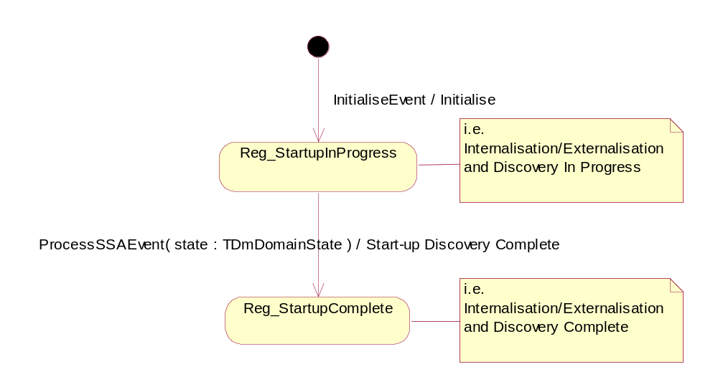
Figure 7: State Machine for Cregistrar

Production Code
- The following changes will be made:
    - Add InitialiseEvent() and call during construction. See state diagram above
- Add iState data member to class to hold the objects current state.
    - Add void ProcessSSAEvent(TdmDomainState aState). It will be used by CserverStartupMgr to notify the object of system start-up state changes. The event may or may not cause the object to move to another state. The allowed transitions are identified in the state diagram shown above.
- Cregistrar holds an instance of Cdiscoverer. ProcessSSAEvent(TdmDomainState aState) must call Cdiscoverer’s implementation of ProcessSSAEvent(TdmDomainState aState). This will ensure that Cdiscoverer is kept up-to-date.
- Add Rstate GetState() to retrieve the objects current state.
- The CbackupNotifier will be created when Cregistrar reaches its Reg_StartupComplete state.
- Testability
  - A class called Tregistrar_StateAccessor already exists to allow unit test code to access protected and private data and operations.
- Configurability
This code will be non-configurable.

Unit Test Code
- The following new unit tests are required:
- After construction check that initial state is Reg_StartupInProgress.
- Call ProcessSSAEvent(TdmDomainState aState) with aState set to Non-Critical. Check that the current state is Reg_StartupComplete.
- Call ProcessSSAEvent (TdmDomainState aState) with aState set to various states that will not cause a transition (see state diagram). Do tests again with Cregistrar in different states. Check that the current state remains unchanged.
- Configurability
This code will be non-configurable.

ECOM Component Tests
- The following new component tests are required:
- Set the System Start-up state to Critical-Static and execute RunL(). This will cause all state driven ECOM objects to move to their corresponding state. Create an ECOM client and call ListImplementations(). Ensure that the request executes successfully. Ensure only implementations from plugins discovered from the Z: drive exist. i.e. there should be no implementations from plugins from the C: drive.
- Set the System Start-up state to Non-Critical and execute RunL(). This will cause all state driven ECOM objects to move to their corresponding state. Create an ECOM client and call ListImplementations(). Ensure that the request executes successfully. Ensure implementations from plugins discovered from the C: drive exist.
These tests use the test harness version of CdmDomain. See 3.1.2.2 Unit Test Code.

ECOM Component Integration Tests
- The following new integration component tests are required:
- Ensure ECOM functions correctly for each start-up state notification received from Domain Manager. i.e. Check that the expected plugins exist in the Registry by using the client API ListImplementations().
- Ensure ECOM functions correctly when ECOM cannot connect to the Domain Manager.
- Ensure ECOM functions correctly when there is no System Starter process present.

ECOM Regression Test Code
Tests that directly link ECOM objects which are now state driven, must be updated so that each object is initialised to its final state. This can be done by calling ProcessSSAEvent(TdmDomainState aState) on each object with the Non-Critical state.
No change is needed to tests that use EcomServer. There are 3 possible scenarios all resulting in ECOM doing a full discovery:
- System starter is present and ECOM connects to the Domain Manager – normal Staged Start-up operation in which ECOM will do a full discovery.
- System starter is not present and ECOM connects to the Domain Manager – The Domain Manager will return Non-Critical state causing ECOM to do a full discovery.
- CdmDomain::ConstructL() leaves because it cannot connect to the Domain Manager. ECOM code manages this by doing a full discovery.

ECOM Client Library
There is 1 minor impact to ECOM clients using the ListImplementationsL() API’s due to the changes outlined in 3.1 ECOM Server.
This impact is covered by break request BR.1441 raised by SMG.

Possible for Client to Select Plugin Based on Incomplete List

Current Behaviour
ECOM completes all of its start-up discovery across all drive units in one go. Therefore on completion all implementations from all drive units are available to clients.

New Behaviour
With the introduction of Staged Start-up ECOM does its start-up discovery in stages.
Implementations on drive units that are “internal RO” (e.g. Z drive unit) will be available to clients when Critical-Static start-up state is reached.
Implementations on drive units that are “not internal RO” (e.g. C drive unit) will only become available to clients when Non-Critical start-up state is reached.

Phase II Modifications
New TpluginProcessingTypeIdentifier enumerated type will be defined in DiscovererObserver.h header file. The type will define the following values:
- EpluginProcessingTypeNonCriticalOnly //plugins discovered non-critical stage of start-up
- EpluginProcessingTypeCriticalOnly //plugins discovered at critical stage of start-up
- EpluginProcessingTypeAll //all plugins
These values will be used to selectively process plugins.

MdiscovererObserver
DiscoveriesComplete method prototype will be modified to allow selective processing of plugins:
MdiscovererObserver::DiscoveriesComplete(Tbool aSuccessful, TecomProcessingTypeIdentifier aProcessingType)

Cregistrar
DiscoveriesComplete method prototype will be modified to allow selective processing of plugins:
Cregistrar::DiscoveriesComplete(Tbool aSuccessful, TecomProcessingTypeIdentifier aProcessingType)
DiscoveriesCompleteL method will pass aProcessingType parameter to CregistryData::DiscoveriesCompleteL in order to allow for selective processing of plugins based on ECOM server start-up state.

CregistryData
CregistryData::DiscoveriesCompleteL method prototype will be modified to allow selective processing of plugins:
CregistryData::DiscoveriesCompleteL(Tbool aSuccessful, TecomProcessingTypeIdentifier aProcessingType)
DiscoveriesCompleteL method will pass aProcessingType parameter to all methods that process plugins in order to allow for selective processing of plugins based on ECOM server start-up state.
This method calls 3 methods that repeat the same functionality for each state of start-up. These methods are:
- CregistryData::ValidateRegistry
- CregistryData::BuildIndexesL
- CregistryData::PersistNowL

ValidateRegistry Method
Modify method prototype to CregistryData::ValidateRegistry(TecomProcessingTypeIdentifier aProcessingType)
The method will be modified to validate only the drives that are needed based on aProcessingType parameter.

PersistNowL Method
Modify method prototype to CregistryData::PersistNowL(TecomProcessingTypeIdentifier aProcessingType)
The method will be modified to persist only the drives that are needed based on aProcessingType parameter.
CregistryData::PersistNowL method uses CregistryData::ExternalizeL method to persist the drives. The aProcessingType parameter needs to be passed to the ExternalizeL method to selectively persist drives. The CregistryData::ExternalizeL method prototype will be modified to:
CregistryData::ExternalizeL(RfileWriteStream& aStore, TecomProcessingTypeIdentifier aProcessingType)

BuildIndexesL Method
The CR named Address “Ecom Plug-in Upgrade” security threat [4] includes integrating the functionality of CregistryData::BuildIndexesL method into the Cdiscovery class code. When this work is complete the repetition that is in the current SSA code will not be there it is wasted effort as the code will subsequently be removed.

Other Changes
- The ~CregistryData will be modified to call PersistNowL method with Eecom_ProcessAll parameter.
- CregistryData::iFileReadStream, CregistryData::iIsEcomIdxfileCorrupted data members for CregistryData are used only within CregistryData::CreateDriveListsL method. Therefore they will be made into local variables for the method and removed from the class description.

Cdiscoverer
- All the calls to MdiscovererObserver::DiscoveriesCompleteL has to be revisited as follows:
- ScanDirectoryIncrementL will call DiscoveriesCompleteL with Eecom_ProcessAll parameter.
- ScanDirectoryCancel will call DiscoveriesCompleteL with Eecom_ProcessAll parameter.
- ProcessSSAEventL will call DiscoveriesCompleteL with Eecom_ProcessStaticOnly when iState is Edisc_NoPluginsDisc and aKnownState is EstartupStateCriticalStatic. i.e. when critical-static start-up state is being processed.
- ProcessSSAEventL will call DiscoveriesCompleteL with Eecom_ProcessNonCriticalOnly when iState is Edisc_CriticalPluginsDisc and aKnownState is EstartupStateNonCritical. i.e. when non-critical start-up state is being processed.
- ProcessSSAEventL will call DiscoveriesCompleteL with Eecom_ProcessAll when iState is Edisc_NoPluginsDisc and aKnownState is EstartupStateNonCritical. i.e. when all plugins are being processed.
- ScanDirectoryIncrementL should be modified to not call CreateDriveListsL method. CreateDriveListsL method should only be called once during Cdiscoverer object initialisation to fill in the iRoDriveList and iNonRoDriveList lists. Once these lists are created their contents will never change so there is no need to delete and re-create them during the life time of Cdiscoverer objects.

CEComServer
The IsSSA method prototype will be modified to:
static Tbool CEComServer::IsSSA(RFs& aFs)
This was we can eliminate opening another file server session.

CserverStartupMgr
The class definition will be modified to include RFs& iFs data member.
The constructor will be modified to accept RFs& aFs to set its iFs data member.
This data member will be used to pass to CEComServer::IsSSA method as an input parameter.

Further Information

Open Issues
None

References
No. | Document Reference | Description
[R1] | http://smglinx.intra/twiki/bin/view/SMG/GenericBoot | Generic Start-up Investigation
[R2] | TBD – Draft 0.3, 2005-01-26 | Start-up State Aware Adaptation – How To, author Matthew Reynolds
[R3] | TBD – Draft 0.1, 2005-01-26 | SMG Design Sketch for PREQ 967, author Matthew Reynolds
[R4] | V:\Dev\TS\TS0017 Base Services\RequirementsAnalysis\ProductRequirements\PREQ967\ SGL.TS0017.513 PREQ967 Design Sketch_1.0.doc | SysLibs Design Sketch for PREQ 967
[R5] | SMAD-65BCA3 | Address “Ecom Plug-in Upgrade” security threat

People
Role | Person / People
Reviewers | Stephen Mansfield
Contributors | Simon Conway, Stephen Mansfield
Location | V:\Dev\GT\GT 0250 System Libraries\Technical\PREQ967

Document History
Date | Version | Status | Author | Description
2005-02-10 | 0.1 | Draft | Simon Conway | First draft
2005-03-11 | 0.2 | Draft | Simon Conway | Update after document review
2005-03-14 | 1.0 | Issued | Simon Conway | Issued
2005-04-06 | 1.1 | Issued | Simon Conway | Changed requirements for CregistryData::BuildIndexes() in 3.1.4 CregistryData.  A number of minor changes.
2005-05-30 | 1.2 | Issued | Cemile Otkunc | Unit test design is updated.
2005-06-20 | 2.0 | Draft | Cemile Otkunc | Design for performance improvements related to this PREQ
2005-07-08 | 2.1 | Draft | Cemile Otkunc | Updates after document review.
2005-08-11 | 3.0 | Issued | Cemile Otkunc | Issued after Simon Conway’s review.
2006-01-04 | 3.1 | For review | Pauline Pan | Defect fix: DEF075122
2006-01-10 | 4.0 | Issued | Pauline Pan | Issued after Simon Conway’s review For DEF075122

